Pot-holed history of an early road near Ardrahan
Ardrahan Heritage Milestones Cycle Ride 27 September 2020

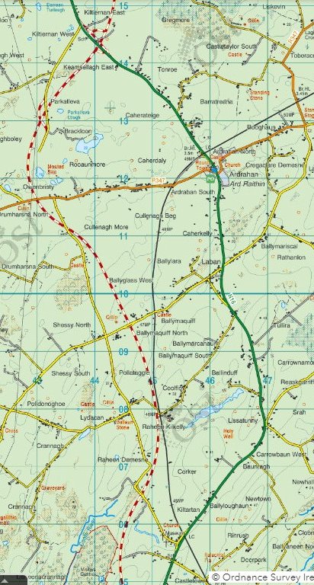
Today we are cycling on part of an old road between Gort and Galway. It runs west of Ardrahan, leaving the main road at Kiltartan and rejoining it at Kiltiernan. Several old milestones survive. The distance between them was an Irish mile (1.27 English miles). Milestones indicated distances to travellers, helped coach drivers to keep to schedule, and were used to measure the fees for coach journeys and postage, and for changing horses at coaching inns.
From 1634 until 1898, when our current local authorities were established, public roads were mostly the responsibility of the county Grand Juries and were paid for with local taxes.
From 1729 to 1858 there were also tolled roads, built by private ‘trusts’ licensed to collect toll fees at wooden gates called ‘turnpikes’. One of the first routes, from 1733, was between Limerick and Ennis. This was afterwards extended to Tubber, near the county boundary with Galway.
The Irish postal service was established in 1783 and mail coaches began to operate long-distance services from 1789. An Act of 1805 gave the Post Office responsibility for surveying the mail coach roads and instructing maintenance works.
OSI Discovery map extract showing the main road through Ardrahan (green), M18 motorway (red-and-white) and the old coach road, now part of the local road network (yellow), indicated by blue arrows on the cycle route (grey for the remainder) with red arrows for the cycle route on other public roads.
So, who built and maintained our old road? In 1778 George Taylor and Andrew Skinner published the Maps of the Roads of Ireland. On the route between Limerick and Galway, the maps show a toll gate (‘turnpike’) at milestone 26, on the county boundary (‘Enter Galway Co.’). Milestones 34 (Kiltartan) to 38 (Kiltiernan) are on our surviving sector of the old road. But there was no turnpike in south Galway and the mail coaches had not yet begun to operate when these local milestones were mapped in 1777, so they were probably erected by the Grand Jury on a coach road, sometime in the mid-18th century, for the benefit of all sorts of travellers between Gort and Galway.
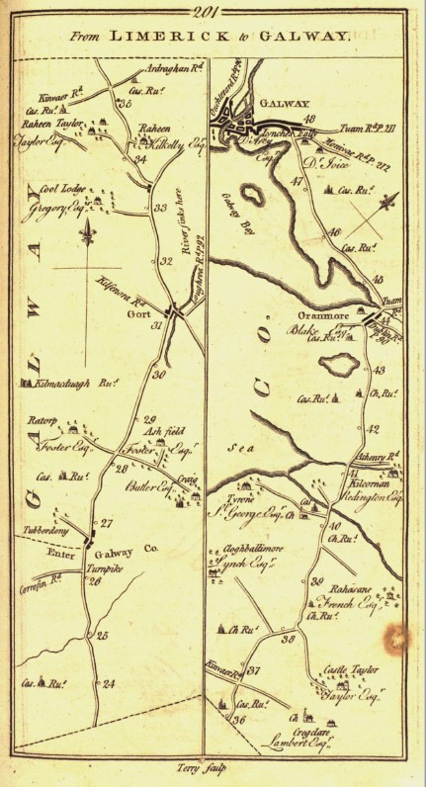
Extract from Taylor and Skinner’s Maps of the Roads of Ireland surveyed in 1777, showing part of the main road from Limerick to Galway. This deviates from today’s main road at Kiltartan (after milestone 33) and joins it again at Kiltiernan (after milestone 38). Ardrahan is not shown because it was bypassed by this road. Maps of the Roads of Ireland is free to view and download at www.askaboutireland.ie

